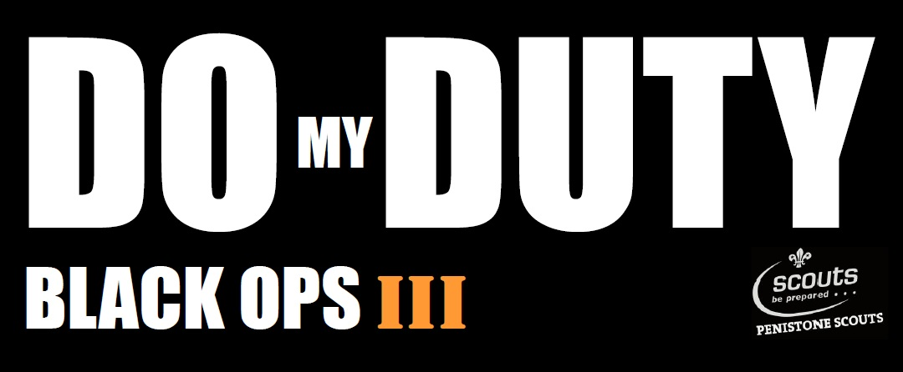
3rd to 5th November 2017 - SILVERWOOD CAMP SITE

Dear Scouts

Fancy a weekend of camping & survival skills with a twist?

BLACK OPS III camp will be full of camping, cooking & survival skills with mini missions, night exercises and a SPECIAL SEARCH & DESTROY ASSIGNMENT which will feature minefields, laser trip wires, smoke bombs, enemy bases and lots more...

The cost of the weekend is £25 which includes all food, camping, activities and a souvenir morf scarf.

If you would like to attend please return the monies (cheques payable to “Penistone Scouts Viernes”) and the attached consent form to your section leader NO LATER THAN FRIDAY 20TH OCTOBER!

We have also provided a kit list; please pay particular attention to the items listed as there are one or two items which are not the norm.

We trust this is acceptable, if you have any queries please do not hesitate to contact me.

Yours in Scouting

Bruce
Penistone Scouts
bruce68@hotmail.co.uk
Tel: 01226 762081
Mobile: 07921 766357

BLACK OPS III CAMP
KIT LIST
To be worn on arrival
Uniform Shirt
Group Necker with Woggle
Luggage – (Contained in one large bag / rucksack)
Sleeping Bag (3/4 Season)
Sleeping Mat
Blanket
Toiletries & Towel
Suitable and enough clothing for weather and length of trip (T-shirts, Jumper, waterproofs, warm top / hoody, underwear etc..)
Walking Boots or Shoes (Strong toecap - FOR USE WITH AXE AND SAW)
Indoor footwear
Cutlery (Knife, Fork, Spoon, Tea Towel, Plate, Mug & Bowl)
Drinks Bottle
Pen / Pencil
Notebook / Diary
Plastic Bag for dirty washing
Mission Gear - DARK or BLACK
Outer Clothing - coat / hoody & trousers
Hat & Gloves
Optional
Penknife - Scouts may bring a penknife but it must be of a folding type (e.g. Swiss Army Penknife - NOT fixed blade)
PLEASE mark all belongings with participants NAME

CONSENT AND HEALTH INFORMATION FORM

THIS FORM MUST BE COMPLETED AND RETURNED BEFORE THE ACTIVITY

Full Name: | Date of Birth:
 | Religion:
Address:
Telephone No (incl. code): (01 )
Emergency Contact Name: |  | Relationship:
Emergency Contact Address (during event):

Full Telephone No (incl. code):
PERMISSION TO TAKE PART (To be completed by parent/guardian)
I hereby agree to my son/daughter taking part in BLACK OPS III CAMP at Silverwood on Friday 3rd to Sunday 5th November 2017 | Signature:  Dated:
MEDICAL INFORMATION (To be completed by parent/guardian)
Doctors Name:
Doctors Address:

Telephone No (day) (Incl. code): (01 ) Telephone No (night) (Incl. code): (01 )
HEALTH INFORMATION (It is important to complete this as fully as possible – continue overleaf)
* delete as necessary |  |  | Give details to “YES” answer.
Are there any medical or health reasons why he/she should not take part in the activity? | *NO/YES
Has he/she been in contact with any infectious illness in the last 3 weeks? (Please inform us of this on the date of departure) | *NO/YES
Does he/she suffer from ASTHMA, HAYFEVER, MIGRAINE, FITS, FAINTS, EPILEPSY, DIABETES, or any other ILLNESS or DISABILITY? | *NO/YES
Is he/she taking any form of regular medication? | *NO/YES
Does he/she suffer from TRAVEL SICKNESS | *NO/YES
Is he/she allergic to ANTIBIOTICS, PLASTERS or any other MEDICINES or FOOD? | *NO/YES
Are there any SPECIAL or DIETARY needs? | *NO/YES
Date of his/her last ANTI-TETANUS injection (if known).

Should the necessity arise, and I cannot be contacted by telephone or any other practical means to authorise urgent medical treatment to the above named, I hereby give my general consent to the Scouter in charge to authorise the medical authorities to give any necessary medical treatment. | Signature:  Dated:
DATA PROTECTION (To be completed by parent/guardian)
I understand that all details including disabilities / religion of the above named will be kept for Scouting purposes only, and that photographs and video may be taken and used for Scouting promotional activities. | Signature:  Dated:

